UKNA Zoom Guidance

Helping to keep our online meetings a safe space to share.

Zoom Settings (HOST)

There are many settings in the Meeting subtab that can also be adjusted, such as disallowing remote control of devices, file transfer, data sharing with Zoom, and screen sharing.

Here are some suggested settings for your meeting to use. Please note that most, if not all, of the settings below, are not the Zoom default:

- Go to: Settings > Recording and click off the Local and Cloud recording features.

In the Zoom Settings section, under the Meeting subtab:

- Require Encryption for Third Party Endpoints
- Disable Autosaving chats
- Disable File transfer
- Disable Feedback to Zoom
- Screen sharing – Enable HOST ONLY (This allows the host to share screen for the readings.
- Disable desktop/screen share for users
- Disable Annotation
- Disable Remote control
- Allow Virtual background (this is the Zoom default and allows the user to use a virtual background instead of the inside of their apartment, for example)

In the Zoom Settings section, under the Recording subtab:

- Disable Local recording
- Disable Cloud recording
- Disable Automatic recording

Reoccurring Meeting - set the meeting up as a “reoccurring meeting” so that the meeting ID doesn’t keep changing.

Having a Host service commitment.

We suggest having a “Host” service commitment for our online meetings. The host will be responsible for monitoring the online meeting environment:

- Muting /unmuting mics.
- Muting video if appropriate.
- Responding to chat requests.
- Bringing the readings up on screen etc.
- Removing people from the meeting (if appropriate)

This then allows the meeting secretary to focus on running the meeting, just as they would in a normal face to face meeting.

Participants - How to Maintain your Anonymity in an Online Zoom Meeting

- Change your name before joining a meeting:

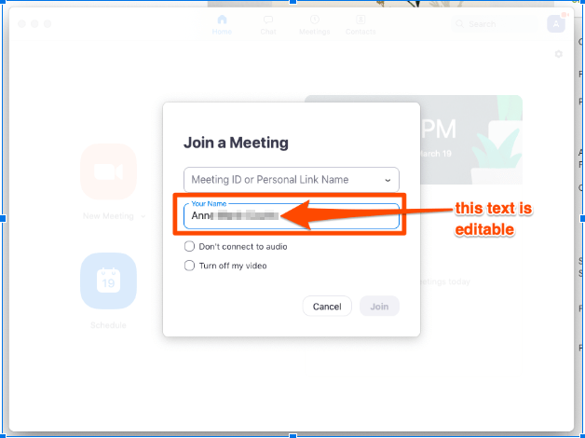

- If you’re concerned about your house showing in the background, sit with your back facing a wall or use a zoom virtual back drop.
- If you’re concerned about being seen on camera at all, you can always disable your video. (Please be aware that some meetings may require you to have video. It may be that you choose a meeting where video is not a requirement)
- You can dial in from your phone so that only your phone number appears, and no video appears (If the meeting allows this).
- You can temporarily turn off your camera and turn it back on if needed (If the meeting allows this).
- Use headphones if you don’t want others in your household to hear.

NA Literature for online meetings.

These resources can be displayed on the screen and or in the chat box, to meet the need of your online meetings. Links to the IPs and booklets can be shared with those new to NA as we make our way through the current health crisis.

- Short “How to…” can be found here: https://www.youtube.com/watch?reload=9&v=i_5oz_Eq47E&feature=youtu.be
- Free NA Recovery Literature can be found here: https://na.org/?ID=ips-eng-index
- Book-length pieces (Basic Text etc,) are available for purchase here: https://www.na.org/?ID=elit
(The book-length pieces can also be purchased and gifted to any addict.)

NA Virtual Resources

- Online Meeting Deck: https://cloud.ukna.org/s/z2xHfcRcmwcGKra
- UKNA Online Meeting Information: https://ukna.org/online
- Web, Phoneline and other Virtual NA Meeting Resources: https://www.na.org/?ID=virtual_meetings

Disruptive Behaviour

How do you deal with disruptive behaviour in an online meeting? We suggest the host messages the person in Chat asking them to stop and if they carry on, mute their microphone and camera. Removal should always be used as a last option.

More guidance on how to deal with disruptive behaviour can be found here: https://na.org/admin/include/spaw2/uploads/pdf/servicemat/2012Jun_Disruptive&Violent_Behavior.pdf

